Student Getting Started Guide

Welcome to Starfish ®
Starfish provides you with a central location to connect to the people and services that can help you finish what you start – all accessible from the side navigation menu of your Starfish Home page.
Log in to your Starfish usig your campus login credentials.
The navigation menu includes access to a customizable profile and personalized channels that make it easy to schedule the dedicated time you need with your instructors, advisors, or counselors. Starfish can also help you manage the steps you need to take to stay on track and meet your goals.
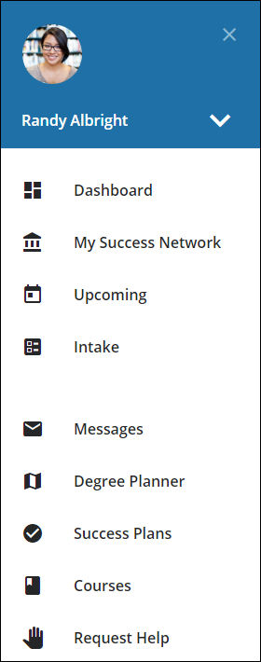
Here are three great ways to get started:
- Set up your profile
Make it easier for your instructors and advisors to get to know you and stay in contact.
- Connect to people and services that can help you
Use your personalized My Success Network and Courses channels for quick access to contact information, appointment scheduling, and course help.
- Stay on track
Use the Upcoming tab to keep track of upcoming appointments, and your personalized Dashboard to see assignments, plans, and recommendations from your instructors.

  - That’s it. Simple for you. Powerful for your future.

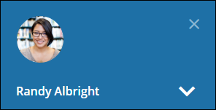
Set up your Profile
Begin by setting up your student profile. Your profile lets instructors and advisors know who you are and how to contact you. It also gives you control over how you wish to receive emails.
- Open the navigation menu and click your name, and then Edit Profile to open your profile.
From here, you can customize your profile by uploading a photo, and adding a secondary email address for receiving Starfish emails.
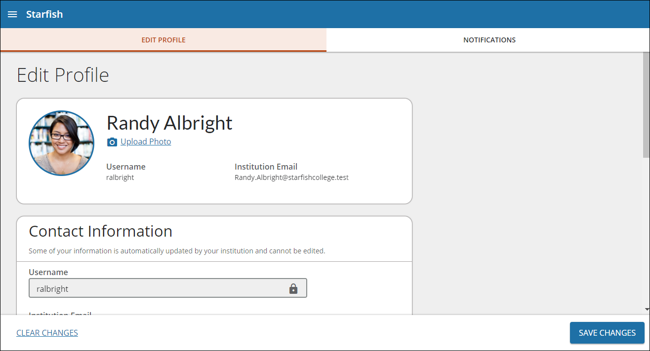
- Select the Notifications tab update your notification preferences.
- Once you have made your desired changes to your profile, click the Save Changes button to save your updates.

Connect to people and services that can help you
The My Success Network and Courses channels display the people and services that are available to help you succeed. Here you can find key contact information as well as links to student service web sites and online appointment scheduling.

Messages
Select Messages to display messages sent to you in Starfish. Click on any message in the list to display the full contents of that message.
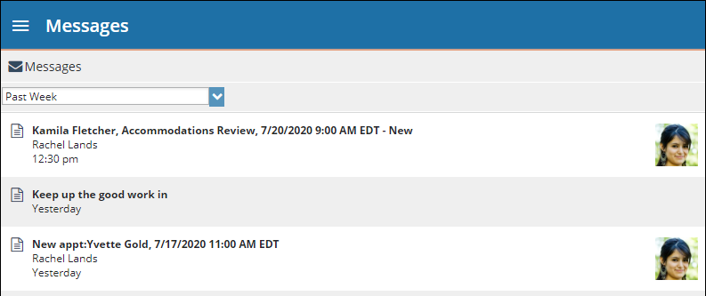

My Success Network
Select My Success Network from the navigation menu to display your personalized network. This channel lists the people and resources that are available to assist you. For each person or service listed, you will find contact information, supporting websites, and, if online scheduling is enabled, a link to Schedule Appointment. If a service includes a waiting room for walk-in appointments, you can click the “Waiting Room” link to find out how many students are currently in line.
The Services that are most relevant to you are displayed first. Select Show Other Services at the bottom of the page to see additional services.
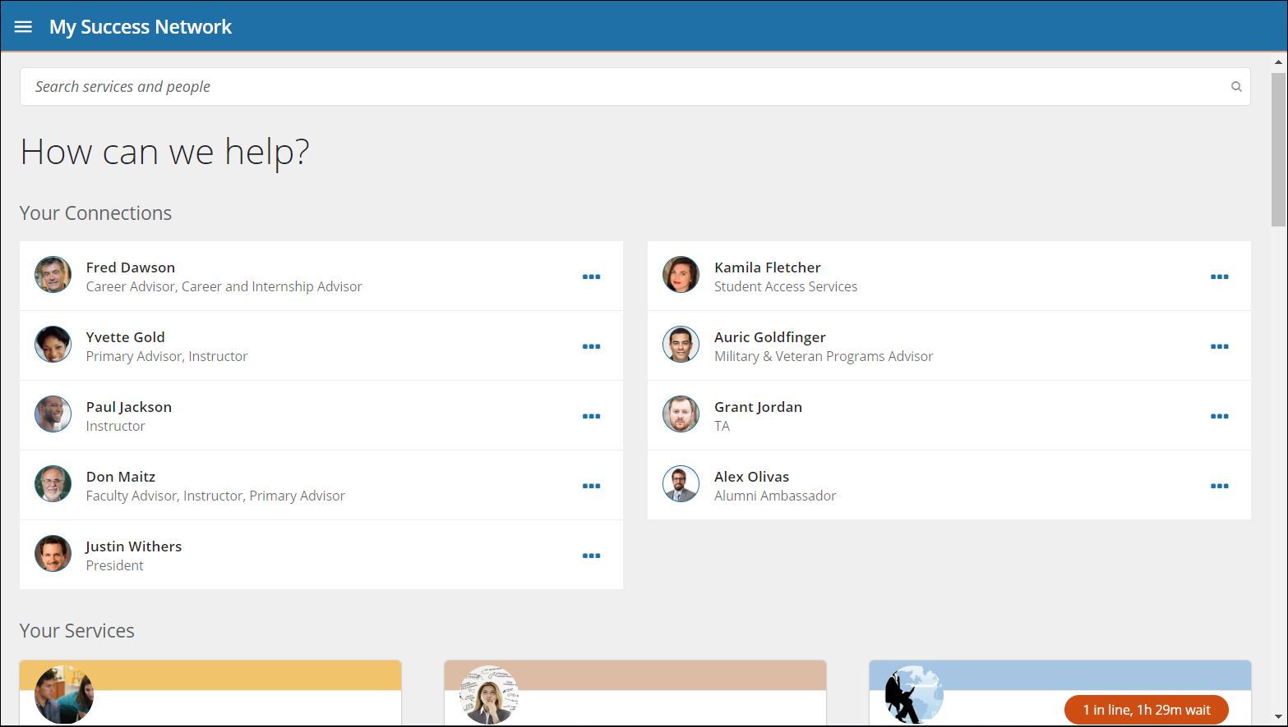

Courses
Select Courses from the side navigation menu to display information about courses you are enrolled in as well as contacts and available support related to each.

Make an Appointment
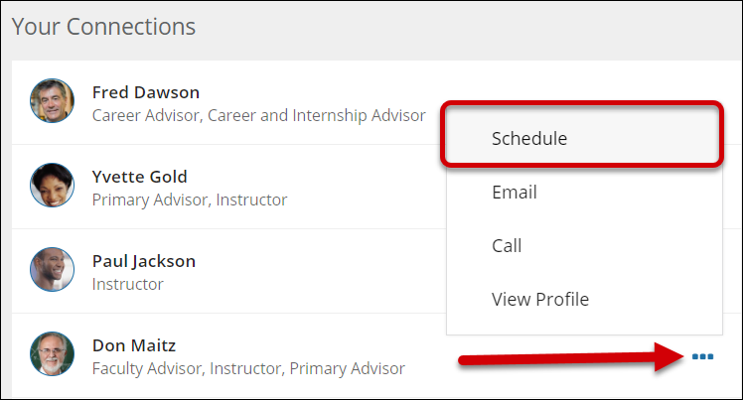
- From the My Success Network, click the ellipsis beside the name of the person you want to schedule an appointment with, and then select Schedule.
For Services where appointments are available, select Schedule for the desired service.

- Select the type of appointment you want to schedule and choose a reason from the list.
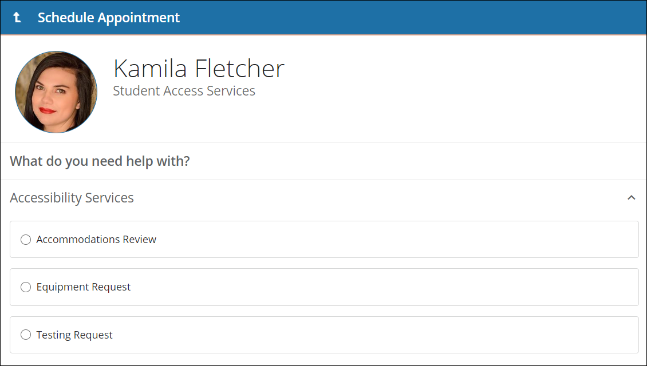
- Adjust the date range as needed to find days and times that work for your schedule, and then select a time from the list.
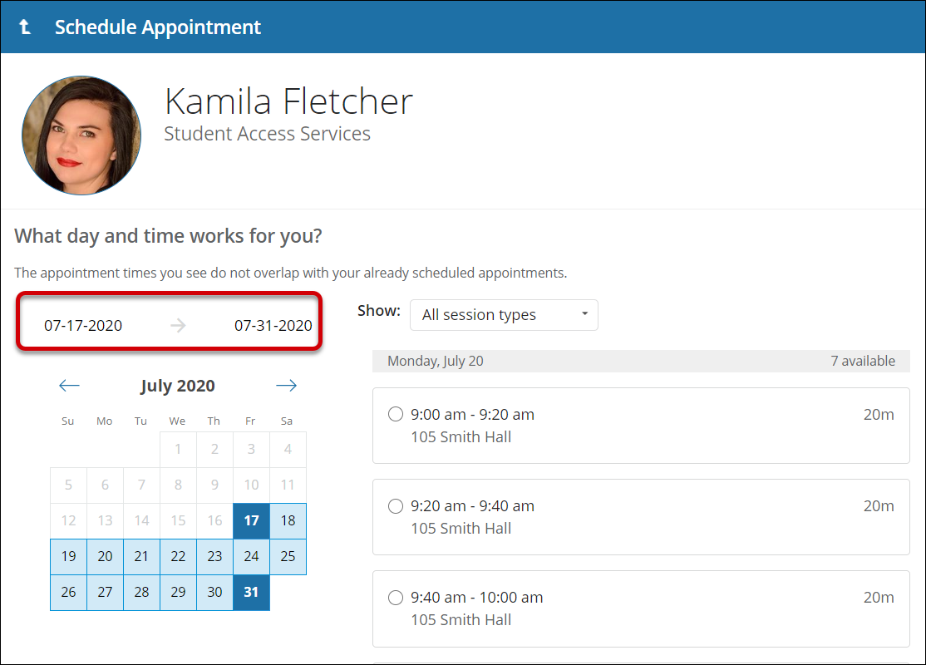
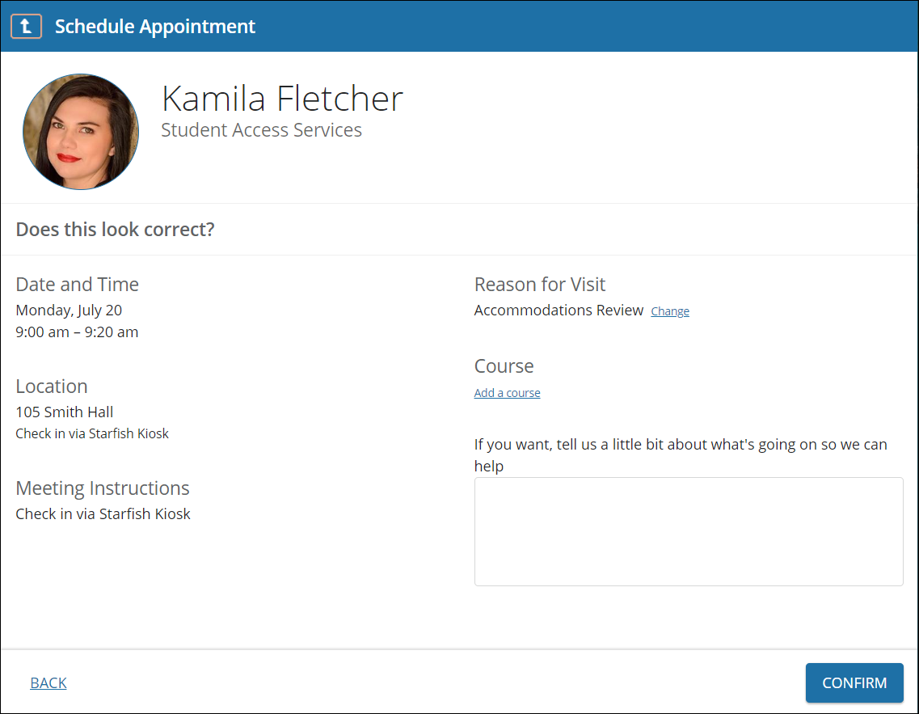
- Complete your sign up by adjusting any details, such as duration or course, where applicable, and add a description for why you want to meet.
- Click Confirm to finish scheduling the appointment. A confirmation page displays allowing you to make changes to the appointment or jump to another page. Additionally, you will get an email with the appointment details and the appointment will be listed on the Upcoming tab.

Change an Appointment
On the Upcoming tab, you can view scheduled appointments and make changes. Click on an appointment to make changes to it, such as changing the location or duration, when available. You can cancel the appointment by clicking the ellipsis and selecting Cancel appointment.
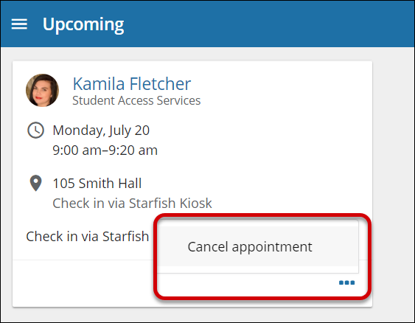

Stay on track

Dashboard
Your Dashboard also displays upcoming appointments as well as date-based tasks on the left to help you plan your week. The right-hand column of your Dashboard highlights items that require your attention and may include alerts related to your class work, recommended referrals to campus support offices to help you succeed, and Kudos from your instructors.
